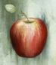

THE ART OF EVE ARNOLD

Image Catalogue 2007

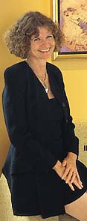

Eve Arnold

M: +61 419 835 381 Fax: +61 8 9284 2578

E: eve@evearnoldart.com www.evearnoldart.com

________________

Photography: Paolo Ferla M: +61 418 896 828
ABOUT EVE ARNOLD

The fruit she eats, the flowers she loves, the relationships she has – they all inspire her work.

Born in Germany, Eve Arnold moved to Sydney in 1973 and has lived in Perth, Western Australia, since 1975.

In 1991 she took up Fine Art studies at Claremont School of Art and later at the WA School of Art, Design and Media and has since held successful exhibitions in Australia, Germany and Italy. She also holds an Advanced Diploma of Arts Management and has managed several fine art galleries as well as being an arts writer.

Eve uses fruit and flowers as a metaphor to explore relationships as well as the sensual and erotic side of life, often touching on the theme of Eve, the Garden of Eden and the Forbidden Fruit. She is also inspired by surface textures and by design elements of the Art Nouveau period.

For many years, watercolour was Eve’s preferred art medium. Applying the dry on dry method, combined with many layers of watercolour glazes, results in a rich, saturated finish, reminiscent of oil paintings. Many of her gilded works evoke ancient icon images.

Under the tutelage of renowned Perth artist Brian McKay, Eve has more recently explored aluminum as a medium. These contemporary, streamlined works are often enriched by accents in 24 carat gold leaf and set themselves apart through simplicity of line whilst still capturing the essence of the subject matter.

Her works are held in institutions and private collections in Australia, Asia, Europe, New Zealand and the USA.

In Australia, Eve has exhibited at Delshan Gallery of Fine Arts, Melbourne, Livewebb Art Gallery, Mt Lawley, Perth Galleries, Subiaco, Accent Gallery, Subiaco and Dalkeith andYallingup Galleries, Yallingup. In 2001 she organized and took part in a group exhibition at the Giubbe Rosse Gallery, Florence, as well as having exhibited at the Concorso Nazionale, Riva del Garda, Italy, in 2002, 2003 and 2004, where she received an award each year.

Having been the Administrator of the Perth Jazz Society for five years, Eve feels a strong affinity with the music and was therefore thrilled when celebrated multi Grammy Award winning New York saxophonist Gary Bartz felt a kinship with her paintings while on tour in Perth. He was planning the release of a new album titled Feminine Side, a recording dedicated to the many great female composers and musicians. Gary and Eve discussed his project and decided that, since there was a rapport between the music on the CD and her artwork, they would combine the two disciplines. Eve started creating a work for each song on the recording in preparation for an upcoming exhibition of works in conjunction with a CD launch by the Gary Bartz Quartet.

Awards
2007 Western Australian Department of Culture and the Arts, Business and the Arts Partnership Awards Commission
2004 Gold Award, Concorso Nazionale, Riva del Garda, Italy
2003 Judges’ Choice Award, Concorso Nazionale, Riva del Garda, Italy
2002 Gold Award, Concorso Nazionale, Riva del Garda, Italy

Solo Exhibitions
2003 Kidogo Arthouse, Fremantle
2000 Artist Studio Exhibition, Claremont
1999 Kievernagel Gallery, Düsseldorf/Germany
1998 Kievernagel Gallery, Düsseldorf/Germany
1997 Artist Studio Exhibition, Claremont

Participated in over 50 group exhibitions in Australia, Italy and Germany between 1996 and 2006

“Eve’s artworks remind me of the best Haiku poetry, combining form and content in a meaningful, yet compact form. They are like meditations; they bring one closer to nature. The subject matter is expressed with a minimum of lines, painting a mental image in the viewer’s mind. As in Haiku, many themes include nature, feelings, or experiences.”
Gart Bartz

“Eve Arnold’s work is delicate and detailed, but with an underlying strength. There is also a subtle playfulness, as she makes gentle puns on her own name, and explores personal experiences. The images are realistic, but have little to do with direct reporting. Rather, the meticulously detailed representation of flowers and fruits lifts them out of the ordinary into the symbolic levels of significance. Her works amply repay a careful and thorough analysis of their deeper meanings.”
Dr. Jan Altmann
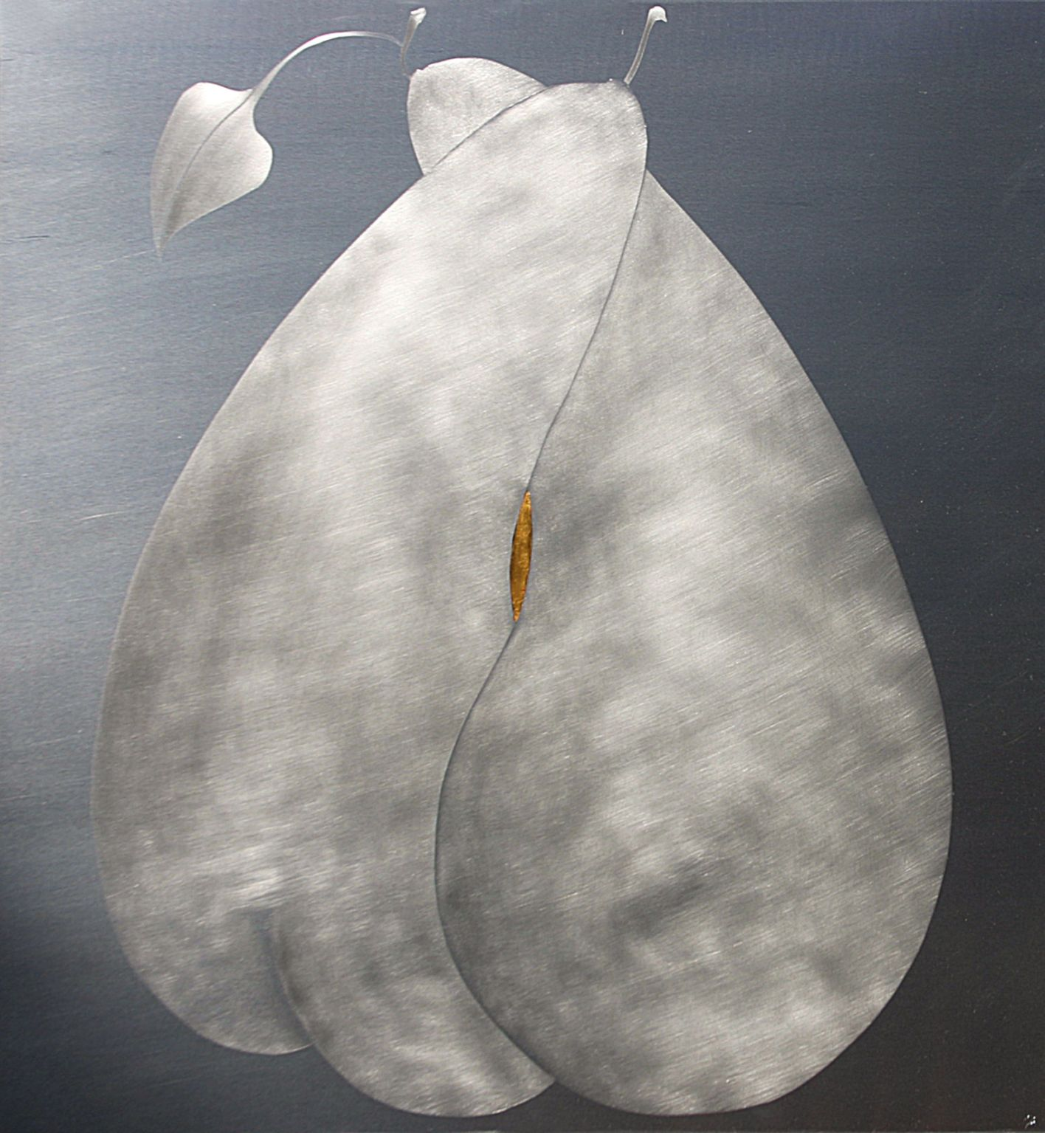
United Together
Aretha Franklin

aluminum and 24ct gold leaf
800 x 800 mm

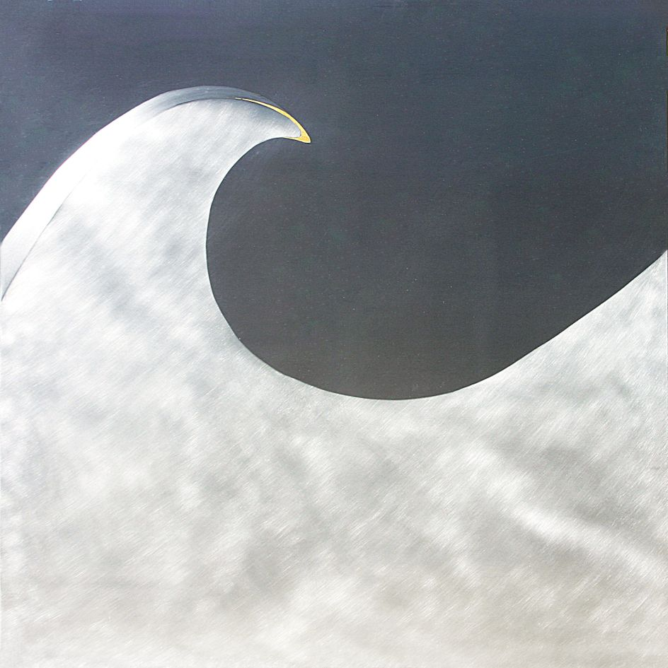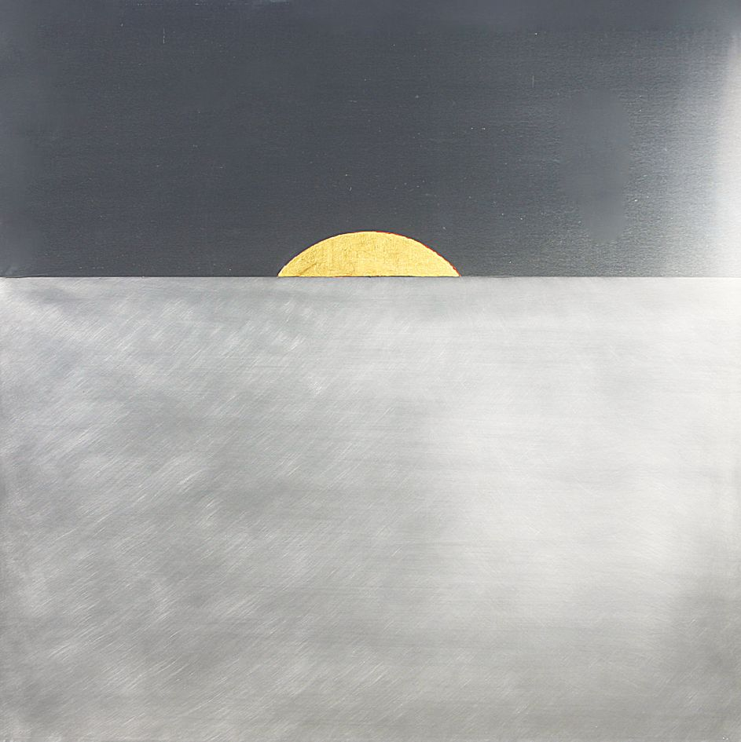

Stormy Weather That Lucky Old Sun
Lena Horne Sarah Vaughn

800 x 800 mm 800 x 800 mm
aluminum and 24ct gold leaf aluminum and 24ct gold leaf

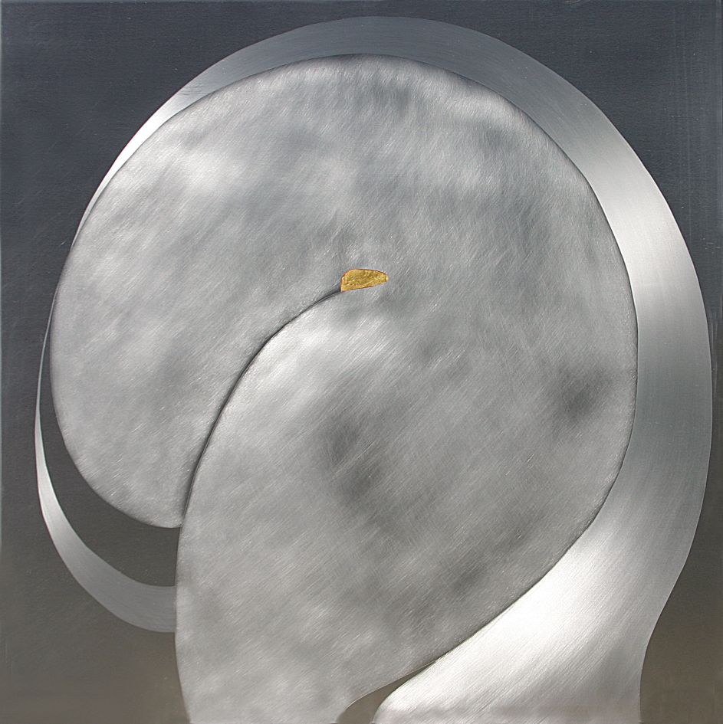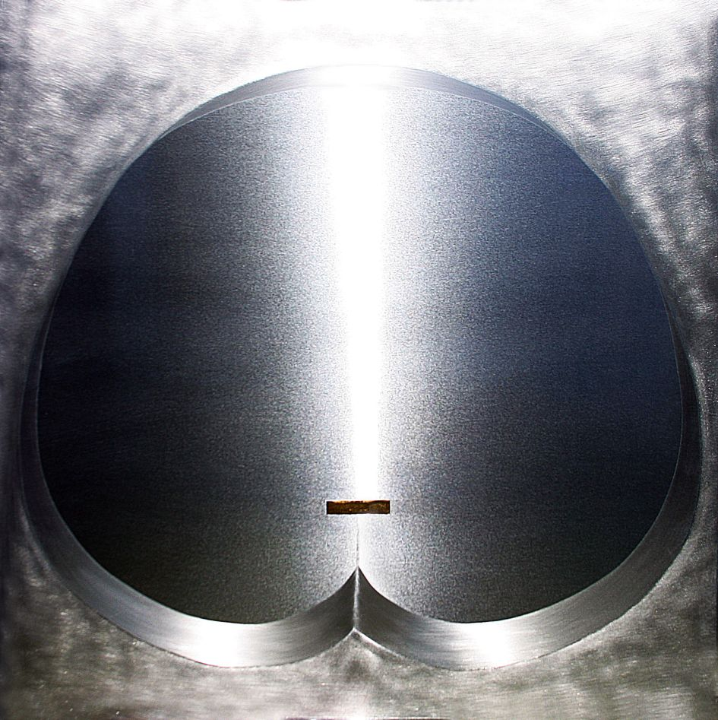

Imagination Somewhere Along The Line
Ella Fitzgerald Dinah Washington

800 x 800 mm 800 x 800 mm
aluminum and 24ct gold leaf aluminum and 24ct gold leaf

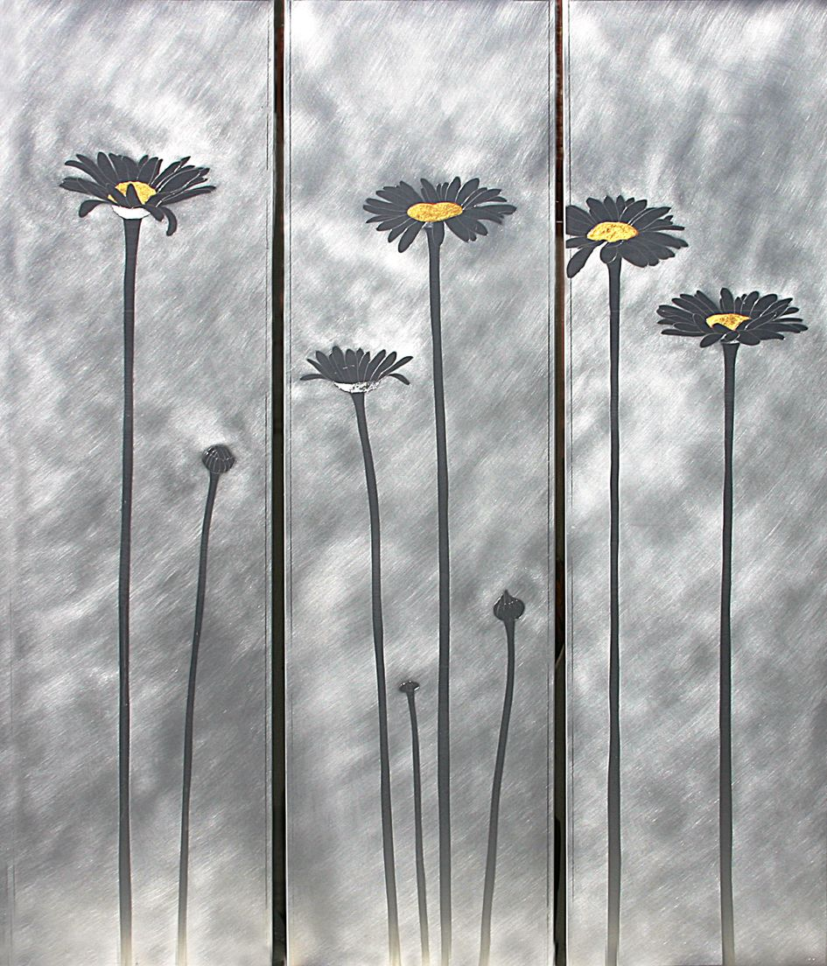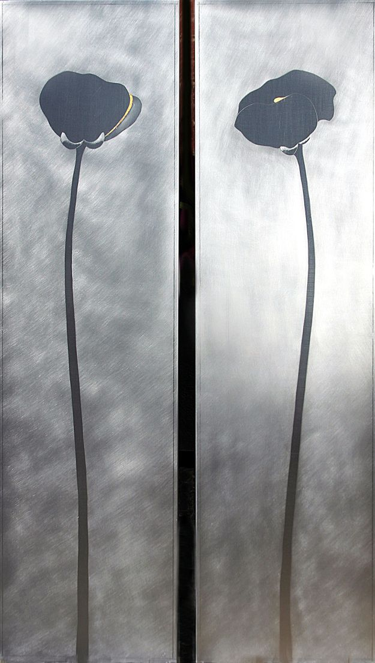

Sweet Seasons (triptych) We’ve Only Just Begun (diptych)
Carole King Karen Carpenter

1100 x 1000 mm 1100 x 650 mm
aluminum and 24ct gold leaf aluminum and 24ct gold leaf

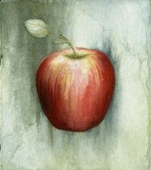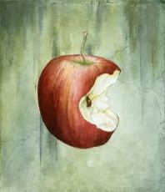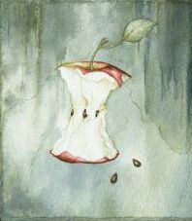

Eve’s Apple (triptych)
Eve’s Song
Gary Bartz

165 x 145 mm each
watercolour on paper

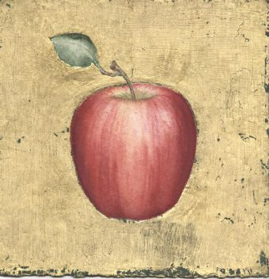

Forbidden Fruit I
watercolour and 24ct gold leaf on paper
160 x 160 mm

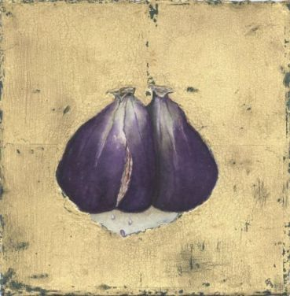

Forbidden Fruit II
watercolour and 24ct gold leaf on paper
160 x 160 mm
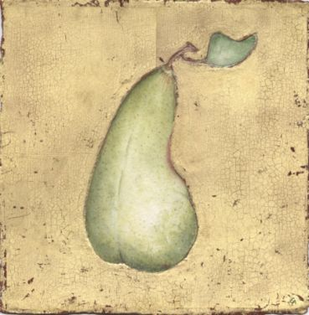

Forbidden Fruit III
watercolour and 24ct gold leaf on paper
160 x 160 mm
 | 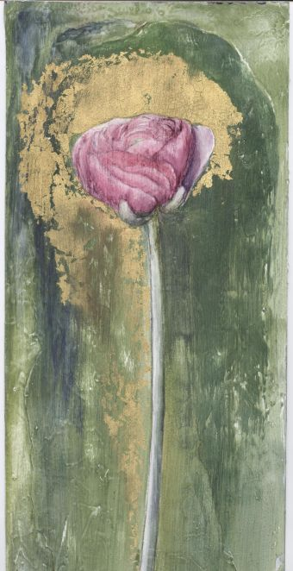 | Two Sides To Every Story  Etta James  front: egg tempera and gold leaf  reverse: study on aluminum  430 x 150 mm

